Welcome to our Autumn Newsletter 2010. As always, we welcome any news or articles that you may wish to add.
New room and new staff
The workmen have been busy striping out the old and putting in the new and the new baby room is getting ever closer to being complete and we will start using it during the week of the 18th October. The new room also incorporates a new cot room which means the existing cot room will become the office. (Peace and quiet at last!)
The new room is for our youngest babies and will be run by Maree, together with Susan, who has recently achieved her NVQ Level 2 qualification. (Well done Susan!) Maree’s expertise is with the babies and she is looking forward to lots of treasure basket and sensory play with the youngest children.
Our toddler room will continue to be overseen by Maree but will be staffed by Pat, Chris and our newly appointed member of staff Lisa Yendole. Lisa comes to us from Little Stars Nursery in Poole and has over 6 years post qualifying experience within Day Nurseries and we are looking forward to welcoming Lisa to our team.
We have also added an additional children’s toilet and also a new buggy shed. This is a storage area located by the fence in the car park for parents to use if they need to leave a buggy or car seat with us during the day.
Finally, I’d like to welcome Becca Fish to the nursery. Becca is on a placement with us from Ferndown Upper School and will be with us on a Tuesday, Wednesday and Friday until Easter next year. I’m sure she will really enjoy her time with us and will also find it beneficial to her CACHE Level 3 course.
Labelling your child’s belongings
Can I please remind all parents about labelling your child’s belongings. While all the staff take great care in ensuring nothing gets misplaced or sent home in the wrong bag, they’re job becomes harder when there is no name to help them identify the owner, especially when we have three pairs of identical shoes to try and reunite with the right child!
I have attached details of a company that we have recommended for several years at our Ringwood nursery that provide very reasonably priced labels that even come with a guarantee!
Christmas...yes sorry Christmas!
It is fast approaching but also very exciting as this will be our first Christmas at Redhill. The staff have lots of things planned for the children in the lead up to Christmas and we will be holding activity afternoons which parents, grandparents or carers are invited to join us for and details of dates and times will follow soon.
The nursery will be closing at 5pm on Friday 24th December and reopening on Tuesday 4th January 2011. For those children in receipt of Education Funding the last session will be Friday 17th December

Christmas Fayre
We will be hosting a Christmas Fayre on the evening of the 10th November between 7.30pm and 9.30pm. Attending will be a variety of traders selling jewellery, cards and wrapping paper, children’s traditional and modern toys (like the sock toy lady!) accessories for the home and bath, and a lady who sells personalised chocolates.
Come along and join us for the evening and bring a friend or two with you. There will be mulled wine or juice and of course a mince pie or two!
Our vegetable garden...
Hidden at the bottom of the garden in amongst the beans is our very own Pumpkin and it has just started to turn orange. We have our fingers and toes crossed that it will be ready for our Pumpkin week at the end of October, when we will hollow it out and make some Pumpkin soup!
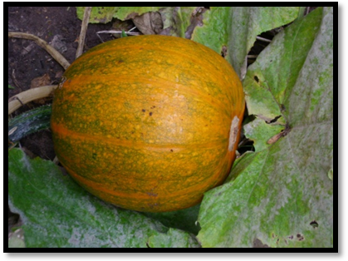
The garden has already given us an endless supply of carrots, potatoes, tomatoes and runner beans and as well as our pumpkin, we now have cabbages, lettuces and more carrots growing. We wouldn’t have had such a successful harvest without the help of the children who have watered and picked the vegetables and most importantly of all....eaten them!
Outdoor play
We are now able to provide all-in-one wet weather suits for all the children in our pre-school and toddler room. We have a smart new wellie boot stand which means we are able to store a pair of boots for your child to use while at nursery.
All of these things mean that we will be spending just as much time outside as we do now, even when the weather isn’t so kind to us!
We have also been selected by Sainsbury’s Active Kids team to receive a tree pack through their ‘Tree’s for Schools’ scheme. We will receive 30 trees in November and will be planting them during National Tree week at the end of the month. It will be lovely to see the tree’s grow as the setting continues to grow too.
Safety
Can I please remind everyone to take great care when exiting the property as there are pedestrians using the footpath who can sometimes be hidden by the wall.

